**Step 1: Deploy a VM from the Previously Created Image**

1. **Log in to the Azure Portal**:
   * Go to the [Azure Portal](https://portal.azure.com) and sign in.
2. **Create a New Virtual Machine from the Image**:
   * Click on **"Create a resource"** from the left-hand menu.
   * In the **"Image"** section, select **"My Items"** to find your previously created image.
   * Choose the image you created earlier.

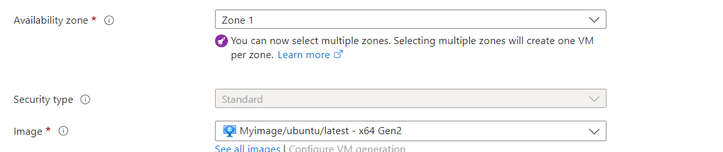

1. **Configure the VM Basics**:
   * Fill in the required fields, such as **Subscription**, **Resource Group**, **VM Name**, **Region**, **Size**, and **Administrator Account** (same credentials as before, if applicable).
2. **Configure Networking**:
   * Ensure the VM is attached to the correct virtual network and subnet.
   * Ensure a Public IP is assigned.
3. **Review + Create**:
   * Review your configurations and click **"Create"** to deploy the VM from the image. Wait for the deployment to complete.

**Step 2: Open Port 80 in Network Security Group (NSG)**

1. **Go to the NSG**:
   * In the Azure Portal, navigate to **"Networking"** from the VM’s left menu or search for **"Network Security Groups"** in the portal.
2. **Select the NSG Associated with the VM**:
   * Find and select the NSG associated with your VM's network interface.
3. **Add an Inbound Security Rule**:
   * Under **Settings**, click on **"Inbound security rules"**.
   * Click **"Add"** to create a new rule.
     + **Source**: Any
     + **Source port ranges**: *
     + **Destination**: Any
     + **Destination port ranges**: 80
     + **Protocol**: TCP
     + **Action**: Allow
     + **Priority**: (set a priority number that fits within your existing rules, e.g., 1000)
     + **Name**: Give it a name, e.g., "Allow_HTTP"
4. **Click on "Add"** to create the rule.

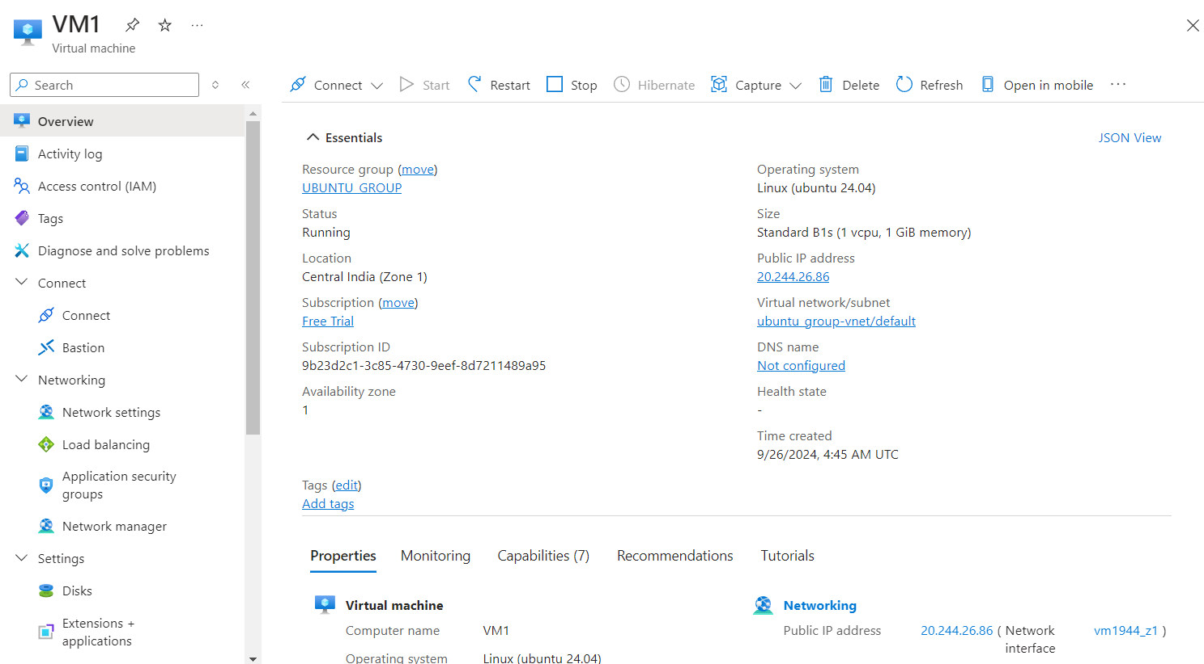

**Step 3: Start the Apache 2 Service in the VM**

1. **Connect to the VM**:
   * Once the VM is running, connect to it using SSH (for Ubuntu) from your terminal:
2. **Start the Apache 2 Service**:
   * Run the following commands to ensure Apache is running:

**sudo systemctl start apache2**

**sudo systemctl enable apache2**

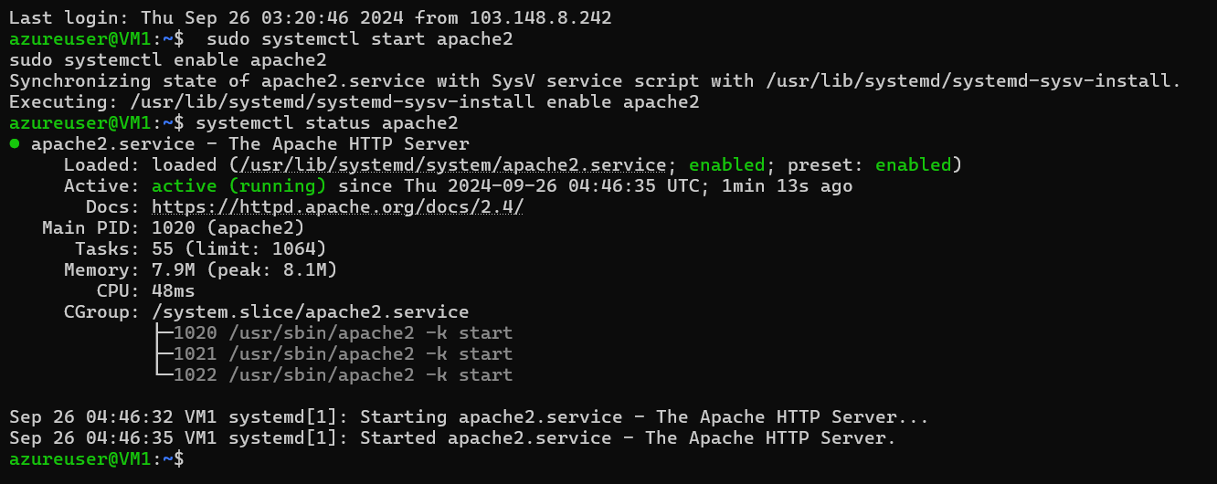

**Step 4: Verify Website Access**

1. **Open a Web Browser**:

